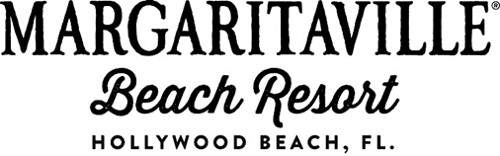

Media Contact:
Samantha Jacobs or Kristin Soto, Hemsworth Communications
954-716-7614 or MVResortPR@HemsworthCommunications.com

MARGARITAVILLE HOLLYWOOD BEACH RESORT ANNOUNCES THREE-DAY HIRING EVENT

New-Build Resort to Stimulate Hollywood Economy; In-Person Applications & Interviews Set for June 23-25
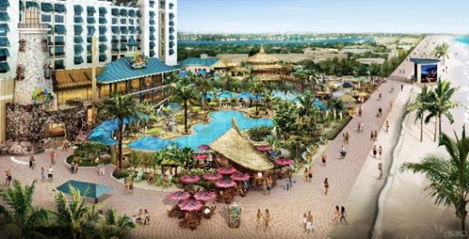
Hollywood, Fla. – June 16, 2015 - The new-build Margaritaville Hollywood Beach Resort (pictured left), preparing to open on the legendary Hollywood Beach Broadwalk in Hollywood, Florida, today announced a three-day hiring event from June 23 through 25. Those looking to join the team can apply and interview in person from 9 a.m. to 4 p.m. each day at Hollywood’s Hillcrest Golf and Country Club.
“We are excited to begin assembling an incredible, passionate team,” said Cate Farmer, the resort’s general manager. “When we open our doors, it will be imperative that Margaritaville Hollywood Beach Resort be known for delivering a high level of service and attention to detail, so enthusiasm and professionalism will be important for those who apply. We are looking for people who will truly love their job and are ready to bring fun and escapism to those who visit us!”
During the hiring event, the resort will accept applications and conduct interviews for positions in hotel operations, housekeeping, security, recreation and wellness, food and beverage and more. For a full list of positions and additional details, visit http://www.margaritavilleresorts.com/careers/hiring-event/.

For more information on the resort or to make a reservation, visit http://www.MargaritavilleResorts.com/ or call (954) 874-4444. Follow Margaritaville Hollywood Beach Resort on Facebook at
https://www.facebook.com/MargaritavilleHollywoodBeachResort and Twitter @Mville_HBR.

About Margaritaville Hollywood Beach Resort
Slated to open in Summer 2015, Margaritaville Hollywood Beach Resort is a 17-story, 349-room destination resort and entertainment complex offering an authentic, “no worries” tropical vibe inspired by the lyrics and lifestyle of singer, songwriter and author Jimmy Buffett. Designed to offer an extensive array of amenities combined with a high degree of hospitality, service and attention to detail, this new oceanfront resort is located just minutes from the Fort Lauderdale-Hollywood International Airport and Port Everglades on the famed Broadwalk in Hollywood, Florida. The perfect setting for guests to escape the everyday and just chill, the resort will feature eight diverse restaurant concepts, a full-service spa with eleven treatment rooms, a state-of-the-art oceanfront fitness center, an array of shopping outlets, 30,000 square-feet of flexible function space, an extensive on-site water recreation area with multiple pools, FlowRider® Double and three live entertainment venues. Margaritaville Hollywood Beach Resort is professionally managed by Coral Hospitality and once open, is expected to achieve the AAA Four Diamond ranking.

# # #

