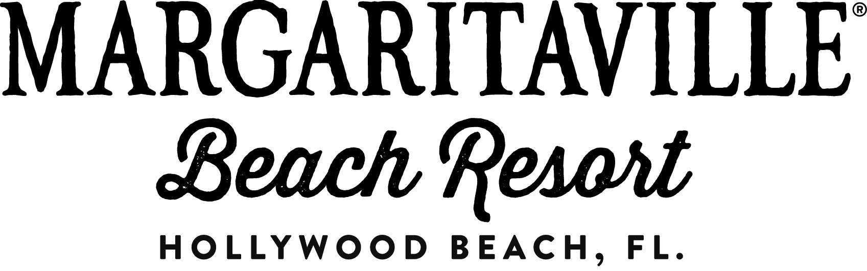
Media Contact: Samantha Jacobs, Hemsworth Communications
954-716-7614 or Samantha.Jacobs@HemsworthCommunications.com

JIMMY BUFFETT GIVES TWO FINS UP TO
NEW MARGARITAVILLE HOLLYWOOD BEACH RESORT

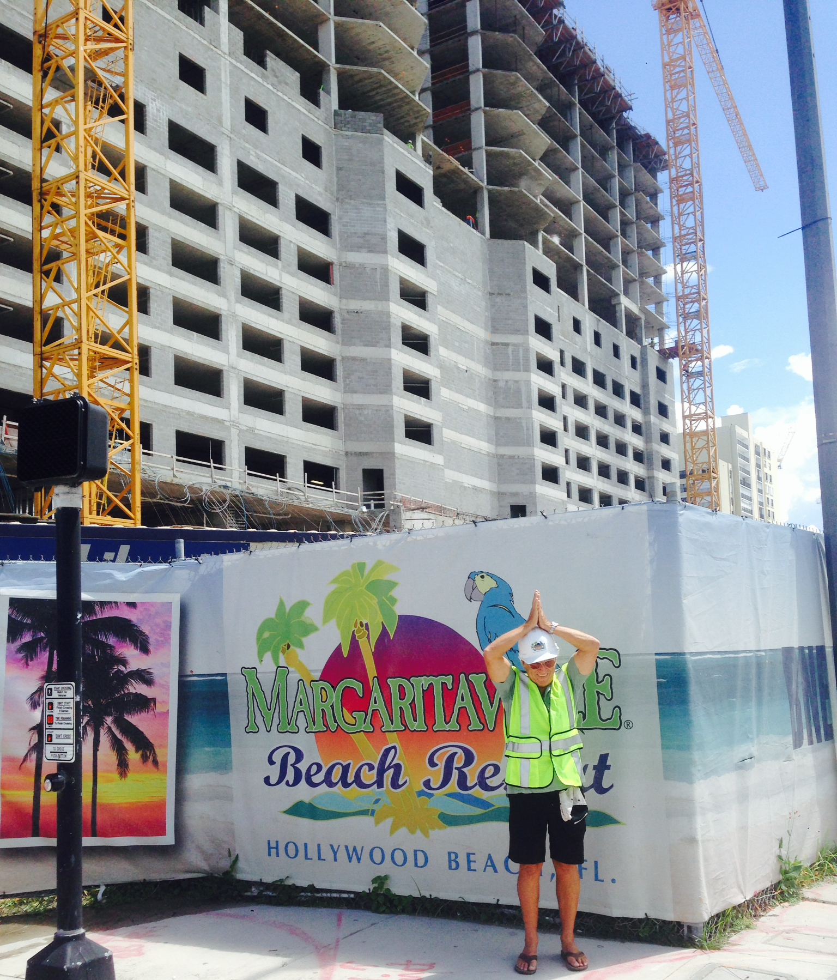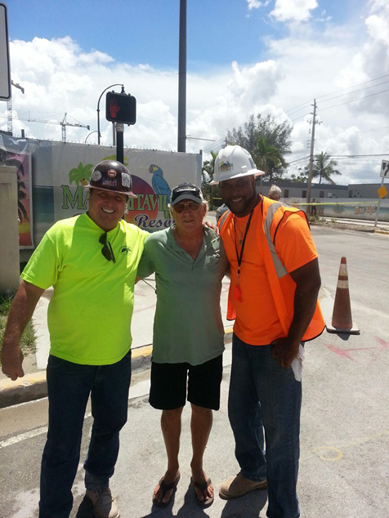
Margaritaville Hollywood Beach Resort Gets Two Fins Up from Jimmy Buffett (left); Buffett meets
with members of construction team, including Danny Hartman (left) and Mike Smith (right)

PHOTO RELEASE – Hollywood, Fla. – September 22, 2014 – Jimmy Buffett created excitement in Hollywood, FL on Friday, September 12, with a surprise visit to the site of the new Margaritaville Hollywood Beach Resort. After a walk-through with the resort’s developer and key members of the team, Buffett gave the property a Margaritaville-inspired two fins up.

With construction on pace for its Summer 2015 grand opening, Margaritaville Hollywood Beach Resort recently revealed a series of updates, including the announcement of its executive team and details on its St. Somewhere Spa, seven diverse food and beverage venues, meeting space and more. The resort expects to mark a major milestone, its topping off, in the coming weeks.

For more information, call (954) 874-4444 or visit www.MargaritavilleResorts.com. Editors – hi-resolution photos available upon request.

# # #

