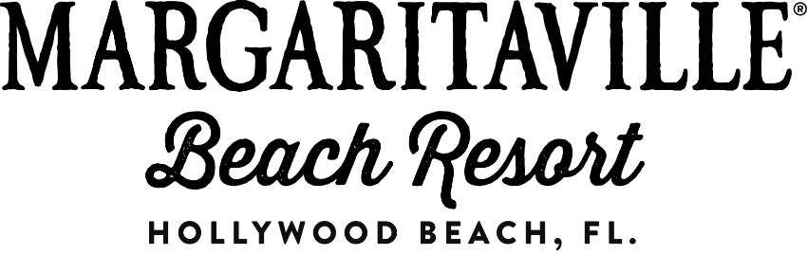

**Media Contact:**

Samantha Jacobs or Kristin Soto, Hemsworth Communications

954-716-7614 or [MVResortPR@HemsworthCommunications.com](mailto:MVResortPR@HemsworthCommunications.com)

**MARGARITAVILLE HOLLYWOOD BEACH RESORT**

**MAKES A SPLASH WITH AN ARRAY OF AQUATIC AMENITIES**

***Resort to Feature Dynamic Multi-Level Waterscape with Three Pools, FlowRider® Double, Two Watersports Areas, Water Taxi Stop & More***

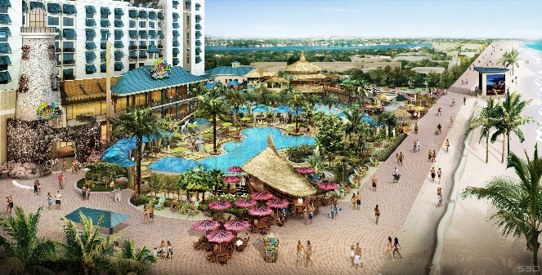

**Hollywood, Fla. – June 2, 2015** – The all-new Margaritaville Hollywood Beach Resort, opening in summer 2015 on the legendary Hollywood Beach Broadwalk in Hollywood, Florida, today announced details on its unique multi-level waterscape, which offers countless ways to enjoy the South Florida sunshine. Appealing to loungers and adrenaline seekers alike, the 349-room resort will feature activities on both the Atlantic Ocean and the Intracoastal Waterway, with two main-level pools; an 11th floor License to Chill rooftop pool; a 20-foot water slide; a unique FlowRider® Double and much more.

“As we approach our opening date, we are thrilled to share details about Margaritaville Hollywood Beach Resort’s dynamic waterscape, which will surely entice travelers to visit us in paradise,” said Cate Farmer, the resort’s general manager. “We are taking advantage of every inch of our incredible location, situated perfectly between the Atlantic Ocean and Intracoastal Waterway, to introduce watersports, activities and amenities that truly define the quintessential tropical destination experience.”

**Beachfront Watersport Paradise**

The resort’s main-level, free-form water recreation area will feature:

* **LandShark Pool** – The resort’s largest pool will include a zero-entry zone, 5,332 square-feet of swimming space and a 20-foot water slide, perfect for families of all ages.
* **Lone Palm Pool** – The resort’s second-largest pool will include 3,172 square-feet of swimming area with a hot tub, the perfect spot to unwind, relax and sip on a signature frozen concoction.



* **FlowRider® Double** – Guests can put their surfing skills to the test, going head-to-head with friends and family with this surfing simulation water feature (*pictured right*).
* **Beach and Snorkeling Adventures** – Guests can spend the day enjoying the famed 2.8 mile sand beach directly from the resort. Whether swimming, snorkeling or paddle boarding, the coastal aquamarine waters of the Atlantic Ocean are truly paradise found.

**Coastal-Luxe Cabanas**

On the main beach-level surrounding its expansive pool area, Margaritaville Hollywood Beach Resort will feature 24 cabanas, boasting the ultimate in comfort. Cabanas will be appointed with flat-screen TVs, mini-refrigerators, locking safes and ceiling fans complementing the cool ocean breezes. When reserved in advance, cabana guests can enjoy personalized bottle service and special menus.

**Interactive Intracoastal Waterway Exploration**

Guests looking to dive into something more adventurous can visit the resort’s

5 o’Clock Somewhere Bar & Grill, located directly on the Intracoastal. After enjoying lunch, dinner or drinks, guests can then embark on a self-guided paddleboard tour along this renowned waterway leading to nature preserves and scenic mangrove covered trails. A Water Taxi stop will also be available here, offering convenient access to nearby shopping centers and local attractions. Details on unique guided excursions and eco-tours will be announced in the coming months.

***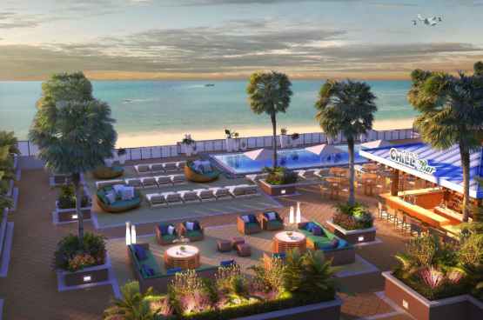*Soothing Rooftop Retreat**

Undeniably the best views on the beach, Margaritaville Hollywood Beach Resort’s 11th floor terrace (*pictured right* overlooks the Atlantic Ocean and features the License to Chill Bar with food and beverage service daily, comfortable seating areas and a 20x30 pool.

The pool, equipped with jets, streams cool water for a refreshing spa-like experience.

**For more information, visit** [**http://www.MargaritavilleResorts.com/**](http://www.MargaritavilleResorts.com/) **or call (954) 874-4444. Follow Margaritaville Hollywood Beach Resort on Facebook at** [**https://www.facebook.com/MargaritavilleHollywoodBeachResort/**](https://www.facebook.com/MargaritavilleHollywoodBeachResort/)**.**

**About Margaritaville Hollywood Beach Resort**

Slated to open in Summer 2015, Margaritaville Hollywood Beach Resort is a 17-story, 349-room destination resort and entertainment complex offering an authentic, “no worries” tropical vibe inspired by the lyrics and lifestyle of singer, songwriter and author Jimmy Buffett. Designed to offer an extensive array of amenities combined with a high degree of hospitality, service and attention to detail, this new oceanfront resort is located just minutes from the Fort Lauderdale-Hollywood International Airport and Port Everglades on the famed Broadwalk in Hollywood, Florida. The perfect setting for guests to escape the everyday and just chill, the resort will feature eight diverse restaurant concepts, a full-service spa with eleven treatment rooms, a state-of-the-art oceanfront fitness center, an array of shopping outlets, 30,000 square-feetof flexible function space, an extensive on-site water recreation area with multiple pools, FlowRider® Double and three live entertainment venues. Margaritaville Hollywood Beach Resort is professionally managed by Coral Hospitality and once open, is expected to achieve the AAA Four Diamond ranking.

# # #